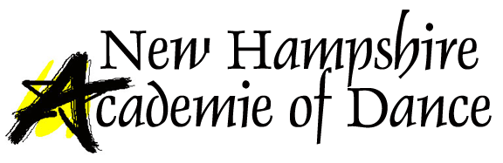
RECITAL PHOTO DAY INFORMATION

Saturday, June 1, 2019
New Hampshire Academie of Dance
8:30am thru early evening
______________________________________________________________________________

Please note there will be NO Saturday classes on Picture Day
Exact photo times will be posted one week prior to photo day
Photos will be available for viewing and purchase at dress rehearsal in the lobby of the Stockbridge Theater between the hours of 4:00pm and 8:00pm
DO NOT ARRIVE IN COSTUME. Dress at the studio and keep your costume in a garment bag. Costumes and dance shoes should not be worn outdoors at any time. We recommend that you do your hair and makeup before you arrive.
Dress your dancer EXACTLY as you would for the show. All hair and makeup done as instructed, though makeup need not be as heavy as for the actual show onstage, Don’t forget all costume items, hair and makeup supplies, shoes, tights, etc.
We request that you make every effort to attend your photo session, as we may use the photos for promotional purposes
Sibling shots are available without commitment to purchase; however, “FRIENDS” shots are available only with commitment to purchase
You may only purchase photos directly from our photographer. We do not deal directly with photo purchases. Their website is donnerphotographic.com
If you miss viewing photos at dress rehearsal, the photographer will contact you via email
Absolutely no parents will be allowed in the room where photos are being taken at any time. Drop your student off at the door with a teacher. There is just not enough room in the studio for parents to come in with their children
Never eat or drink (except clear liquids) in your costumes. If you do need to have a snack, please be sure to wear some sort of cover up to protect your costume.

